macOS Kernel Panic Recovery

If you upgrade to a macOS version that is not supported with your SentinelOne macOS Agent version, your endpoint might experience kernel panic.

To avoid kernel panic, check the [System Requirements](https://support.sentinelone.com/hc/en-us/articles/360004196614-System-Requirements) for macOS Agents before you upgrade your OS and install all available software updates. In most cases, upgrading software prevents kernel panic.

**Symptoms of Kernel Panic**

* A message shows that your computer was restarted: "Your computer restarted because of a problem." After a moment, the computer continues to restart.
* The computer spontaneously restarts.
* A message shows: "You shut down your computer because of a problem."

Use the [guidelines provided by Apple](https://support.apple.com/en-il/HT200553) to diagnose the cause of kernel panic.

***To diagnose SentinelOne as the cause of kernel panic:***

1. Rule out hardware or other software options.
2. See if the kernel panic logs show SentinelOne information.

The kernel panic text is added to the log after you restart the computer, if you did not reset PRAM (the kernel panic text is stored in PRAM until you restart). In Mac OS X v10.6 or later, the logs are located in  /Library/Logs/DiagnosticReports.

If an incompatible SentinelOne Agent is the cause of the kernel panic, use the Mac OS Recovery Mode to unlock the encrypted APFS volume and uninstall the Agent.

***To uninstall the incompatible Agent with Mac OS Recovery Mode:***

1. Hold down the **Command** and **R** keys during the system start to boot into Mac OS Recovery Mode.

Newer Mac computers and some older Mac computers automatically try to start up from macOS Recovery over the Internet, when unable to start up from the built-in recovery system. If this occurs, you see a spinning globe instead of an Apple logo during startup. To manually start up from macOS Recovery over the Internet, hold down **Option-Command-R** or **Shift-Option-Command-R** at startup.

1. Choose the language, as usual (if applicable).
2. From the **macOS Utilities** window, open the **Utilities** menu from the toolbar.
3. Select **Terminal** to launch the Terminal app within Recovery Mode.

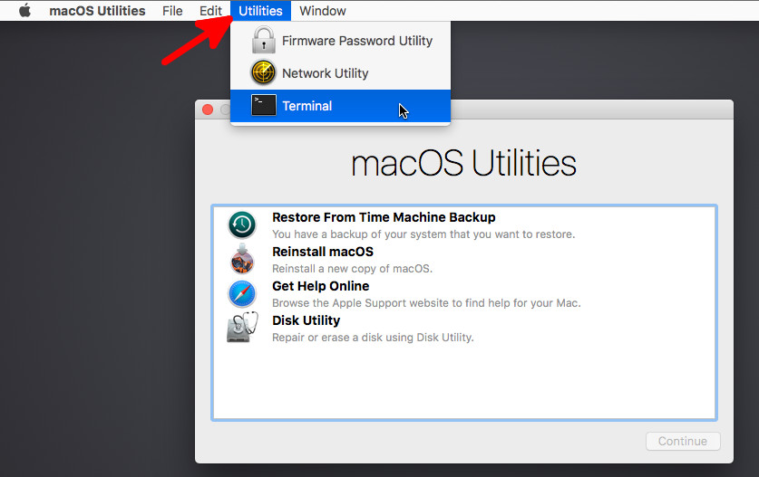

1. Identify the relevant encrypted APFS volume: # diskutil apfs list

For older HFS file systems, use the diskutil list equivalent.

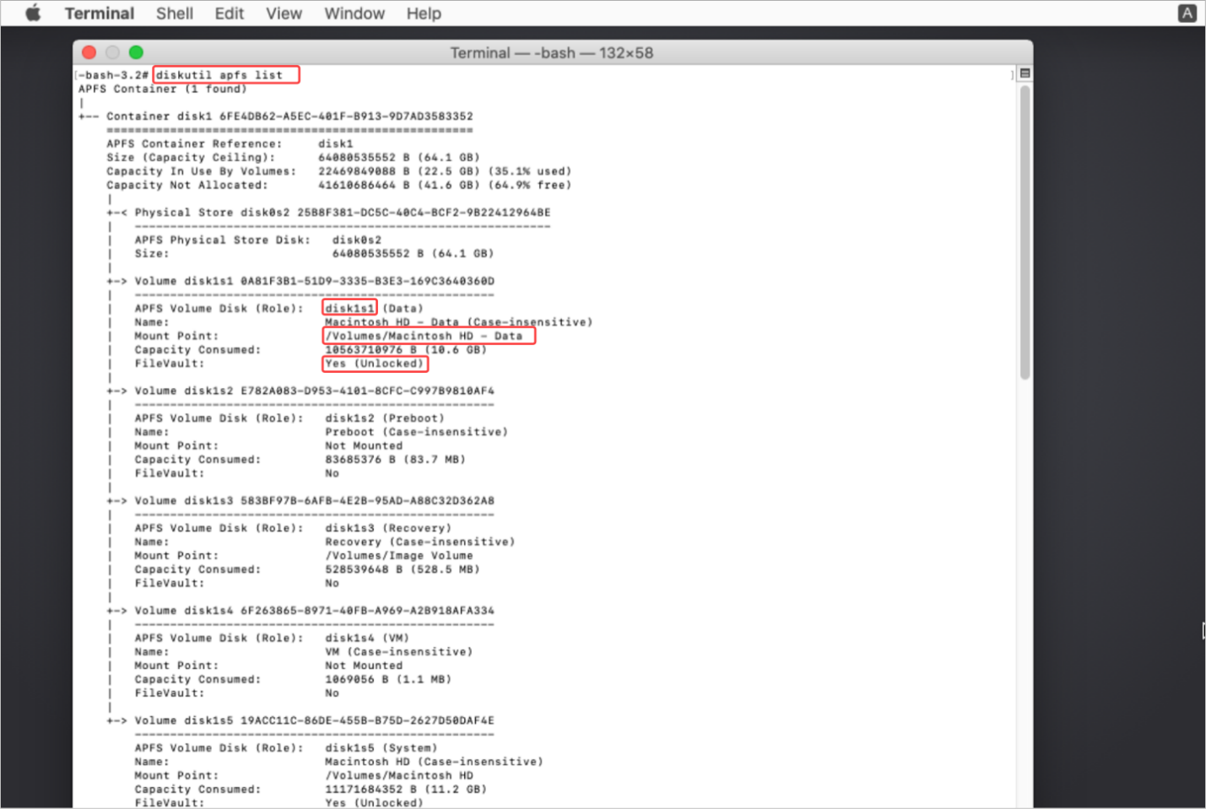

1. Unlock the encrypted APFS volume: # diskutil apfs unlockVolume /dev/<*apfs_volume_id_here*> [-<*passphrase recovery_key_goes_here*>]

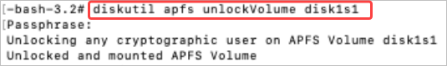

This assumes you have access to the personal recovery key associated with the encrypted APFS volume. If you do not have access to this, use a different option to unlock or decrypt an encrypted APFS boot drive.

1. Uninstall the Agent:
   1. Run: # cd /Volumes/*{apfs mount point}*/Library/Sentinel



* 1. Launch sentinelctl: sentinel-agent.bundle/Contents/MacOS/sentinelctl
  2. Uninstall the Agent: uninstall --local

1. Restart the computer.
2. Install a compatible Agent version.